**Tennis Membership 2025 – Terms and Conditions**

**Fees – the Core Membership – Tennis Only (Pickle is not included)**

Membership fees for 2025 are £100. Members can purchase additional discounts on the tennis that they want most: Indoor Courts, Club Sessions or Group Coaching.

Members are encouraged to pay for their fees and discount packages through the internet. This will involve logging into ClubSpark and selecting the package required.

ClubSpark is the platform provided to us by the Lawn Tennis Association to help us manage our memberships and coaching bookings. Everyone who uses ClubSpark needs to create a login, but once this is done, bookings for parties, coaching and more can be done in the one place. Staff can help members with this, LTA and ClubSpark logins have now merged, which means if you have an LTA login, you may already be able to log into ClubSpark. Please speak to reception if you have any problems.

Once logged into ClubSpark, members can then book group coaching courses and any additional sessions that the club provides. Group coaching discounts are to be applied at the point of purchase through ClubSpark using a discount code, which will be given once you complete your membership purchase.

All fees and discount packages are purchased on an annual basis, although they can be paid by monthly direct debit to help spread the cost. The Direct Debit fee is an additional £2 per month.

All pricing and packages are calculated to reflect a reasonable average number of times a member can play.

Members please note that there are 3 major tournaments each year which close all of the courts, Easter Tournament, August County Championship and October Half Term Grade 3 Tournament.

The club will strive to provide courts for booking from 9am – 9:30pm, except when there are group bookings, coaching, holiday camps, tournaments and netball matches.

Members can sign up for alerts from My Courts (our court booking system) to be notified when courts become available for booking.

Please allow a week after purchasing your membership for your details to be uploaded to the till and My Courts and your membership card to be updated. If you do not have one, you will be issued with a membership card. You will need to present this every time you attend the tennis centre.

**Membership Packages Explained**

**Core Members privileges / discounts**

The Core Member Fees of £100, entitles members to the following privileges:

* Free use of the outdoor courts
* Free cardio tennis sessions
* The annual Jane Watson
* The annual club championship
* Represent the Club in league matches
* Box matches
* 10% discount on food and drink (except Alcohol)
* 10% discount on indoor courts (compared to pay and play price)
* 30% discount on coaching courses (compared to peak pay and play price)
* 50% discount on cost of outdoor lights
* Join club sessions for £5.85
* Can bring a guest to play tennis for £8 per court hour.
* Early court booking window 14 days, compared to a week for pay and play customers
* A Vote at the AGM

**Single Discount Club Membership Packages**

* Tennis Club Sessions Package - Free Tennis Club Sessions - £350 per annum or £31 per month
* Indoor Tennis Court Discount Package - 40% discount on Indoor Tennis Courts - £280 per annum or £26 per month
* Tennis Coaching Discount Package - 40% discount on Tennis Coaching - £280 per annum or £26 per month

Or purchase a combination of discounts and get 18% discount on  your combination of packages

**Double  Discount Club Membership Packages**

* Club Sessions and Court Discount Package   
  Tennis club sessions and Indoor court discount - £453 per annum or £40 per month
* Club Sessions and Coaching Discount Package  
  Club sessions and coaching discount - £453 per annum or £40 per month
* Court Discount and Coaching Discount Package  
  Indoor court discount and coaching discount -  £395 per annum or £35 per month

Or buy all three discounts and get a 20% discount on the supplements

**The Triple Discount Club Membership Package**

Club Sessions,  Indoor Courts and Coaching Discount Package

Indoor Tennis Court Discount / Club Sessions  / Tennis Coaching Discount -  £588 or £51 per month

**Junior Coaching Members**

All juniors who pay for a monthly coaching membership packages have the following privileges:

* Weekly coaching session
* A free Club T Shirt
* 10% Discount on food and drink
* Entry to junior club championship
* Free use of outdoor courts
* Reduced rates on indoor courts
* Winter and summer family events
* Can play for the club when they reach 14 years of age

**Junior Members**

Children who are not on the coaching programme can purchase a membership for £40 per annum, they have the same privileges, but without the weekly coaching course and the club T Shirt.

**Family Annual Outdoor Pass**

A family of 4 can purchase an annual pass to use the outdoor courts. They are not members of the club, and do not have the same privileges as Members. But they can book the outdoor courts and play for free. Courts must be booked in advance. Family Annual Pass - not a membership £85pa, for four people who live in the same household.

**Introductory Membership**

The new introductory Membership 2025 is a half price offer for one year only and has been calculated to include:

* The Core Membership benefits
* Friday Night Intro Coaching Session
* An hour of match play after the Friday night session

The total price for this package would be £324 per annum or £29 per month. For one year only the price is £162 or £16 per month (subject to availability, there are 21 introductory memberships available). After the initial year the full price for the package must be paid or the member must move to an alternative package.

This is an annual membership package and the coaching session only applies to the Friday night session.

**Existing Members**

We will honour existing subscriptions and switch members onto the new Core Membership and packages when they expire. If you want to switch now, we would happily calculate the difference for you and switch you to a new package early, although we cannot refund last years membership if you want to switch to a lower level of membership early.

**Court Booking**

Members are encouraged to book their courts through the MyCourt website. Names of all players should be entered. Payment for courts should be made before you enter the playing area. From January 2025 members must present their membership card in order to get the discount that they have paid for.

Members will not be allowed to return another day and make payment or run up a tab.

**Group Coaching Bookings**

Members are encouraged to book their group coaching through the ClubSpark website. When you select your course, upon reaching the payment window, you need to enter the discount code given to you when purchasing your membership discounts. This will then apply the discount to the price of the course. Codes are for members only, we will know if codes are being given to non-members for use. This kind of misuse of codes will not be accepted and any shortfalls will have to be paid for.

**Tennis Club Sessions**

Only those members with the club session discount can access the club sessions for free. These include the following:

* Monday mornings (summer) (no fee for Core Members)
* Wednesday mornings
* Friday mornings
* Friday evenings

From 1st January 2025, this does not include Pickleball Mixins. See below for more information on why this decision was made. Everyone attending the sessions must present their membership card to reception who will sign them in for the session.

The order of play is managed by a computer which randomises who plays with who. If more people are attending than spaces to play, the plays will be rested on a first come first rested basis, with the hope that no one has to rest more than once in any club session. Players are encouraged to use the outdoor courts to continue play when all of the indoor courts are full.

**Club Championship, Jane Watson, Social Tennis Events**

These events are designed for club members only. However in recent years due to low numbers it has been necessary to open the Jane Watson and the TNT’s to non members. A separate fee schedule will apply in these circumstances for 2025:

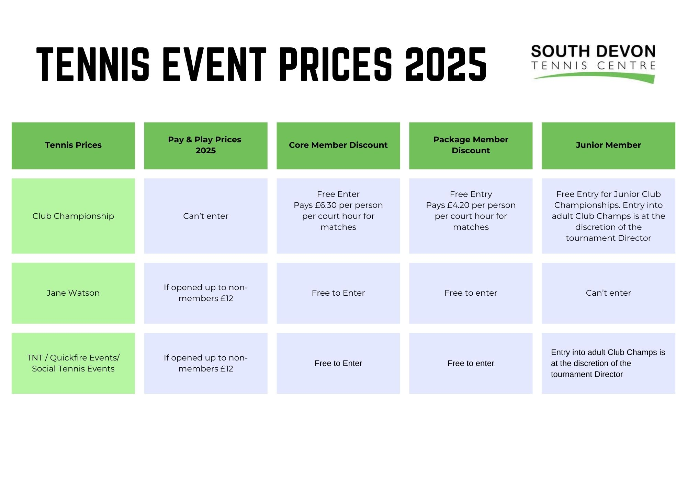

**Guests**

Members are welcome to bring a guest on an occasional basis. This is a privilege of being a member. We realise that It is cheaper to purchase a "Pay & Play" non-member court with three non-members than it is for a members to bring 3 guests. However, the non-member courts can only be booked one week in advance.

Members are reminded that through their membership they get an early booking window. When they bring their guests, the guests are also getting access to the early booking window. Bringing more than one guest on a regular basis is strongly discouraged, as this is giving non-members access to the early booking window. Therefore if courts are booked in this way, the group will charged at the full price of a member and 3 guests – not the pay and play price.

Anyone who wants to access tennis here on a regular basis is encouraged to join the club.

Syndicates can occasionally include a guest to make up numbers, but again this is only on the odd occasion and should not happen on a regular basis. Being able to book syndicates (many operate at peak times) is a privilege for members only.

**Syndicates**

A syndicate is a way of booking a regular court to play with the same 4 people at the same time every week. Bookings are taking for 10 or more weeks consecutively.

Being able to book a syndicate is a privilege of being a members of the tennis centre, therefore the nominated players must all be a member of the club, and hold at least the Core Membership. This is because members of syndicates benefit from booking courts further in advance than other members or visitors.

However, if a syndicate is short of a player occasionally, they can be replaced with a non-member. This should not happen every week. Players who want to regularly play at the club and get the benefits of block booking a court and accessing the early booking window should become members of the club.

Once booked, dates and times of syndicate sessions cannot be rearranged, if syndicate members cannot play on a certain date once booked the captain must seek replacement player/s, as no credit will be given.

The Captain will collect all the correct fees and pay the syndicate cost.

Any member who doesn’t have the “Indoor Court Discount” as part of their package will pay the Core Membership rate.

No more than 2 indoor courts can be used for a syndicate at any one time and any oversubscribed slots will be drawn in a ballot.

We will try our best to allocate the court you wish, there may be times when this might not be possible.

**Playing for the club**

Anyone who purchases a Core Membership can play for the South Devon Tennis Centre in league matches. Individuals in a family who purchase the Annual Outdoor Pass are not members of the club and cannot play for the club. Children over 14 years of age who the coach feels are strong enough can play in the P&D leagues.

The cost of entering a team is £20 per team entry, and the balls for home matches costs £58.77 for the season or £11.75 per home match. Lights and additional staffing to cover matches that go past the centre closure time of 9pm, are then to be added on top of this to the cost of a home match, therefore Members are asked to contribute £3 per person towards the costs (except Juniors). The used balls are then sold by the club after the match to recoup some of the shortfall.

Squash and water will be provided by the club for all players. Additional snacks, cakes and fruit can be provided by the teams themselves should they wish.

It is the captain’s responsibility to collect all of the match fees for the home matches and give them to the centre at the end of the season. This is no longer to be paid through the till.

Members are encouraged to take photos during their matches (seeking permission from the players first) and share them with the club’s management, along with match results through [info@sdtennis.co.uk](mailto:info@sdtennis.co.uk) so that they can be posted on social media.

**Volunteers**

Members are strongly encouraged to get involved with the operations and the management of the club by joining the committee. There are lots of supportive roles that members can take on, where they can use their own personal life and work experiences to benefit the club, they include:

* Committee members
* Social media and marketing
* Club Maintenance and grounds maintenance
* Team Captains
* Reception work / pot washing
* Catering (subject to Food Hygiene certification)
* Project management
* Social / event organising
* Any many more

Volunteer T shirts, training, health and safety and support in all areas will be provided.

**Pickleball**

Pickleball is a new and growing activity that the tennis centre provides to non-members. There are currently no plans to make South Devon Pickleball a club. This is because at the current moment we are not in a position to offer users the same level of membership that can to tennis players via our well-established tennis programme.

Pickleball is too new, for us to confidently ascertain how a membership should work and what value should be placed on it. This is not to say that in the future we may be in a position to create a Pickleball Club and at that point we would consult the South Devon Tennis Centre members, to determine how it could work.

For this reason we have decided to separate Tennis and Pickleball as two different activities and from the launch of the new membership packages in 2025, Pickleball mixins will not be included in any of the tennis membership packages. Anyone wishing to join in with a pickleball mixin, will pay the same fee.